

**FPT ACADEMY INTERNATIONAL**

**FPT – APTECH COMPUTER EDUCATION**

**DOMAIN**

*Amazing Bridges Website*

Development Guide

|  |  |  |  |
| --- | --- | --- | --- |
| **Center Name** | | FPT – Aptech – HCM2  Address: 590 Cach Mang Thang Tam, District 3, Ho Chi Minh City | |
| **Instructor** | | **Mr. Ngo Phuoc Nguyen** | |
| **Class** | | T1.2005.E1 | |
| **Group** | | 4 | |
| **Group members** | | **Name** | **Student ID** |
| *Nguyen Dong Thanh Quang* | *Student1262863* |
| *Le Quang Hien* | *Student1262871* |
| *Nguyen Van Quang* | *Student1266502* |
| *Ngo Quoc Khanh* | *Student1251717* |
| **Duration** | **Start date** | 01 Aug 2020 | |
| **End date** | 01 Sep 2020 | |

**This is to certify that**

**Mr.:**

Nguyen Dong Thanh Quang

Le Quang Hien

Nguyen Van Quang

Ngo Quoc Khanh

**has successfully designed & developed**

eProject: Amazing Bridges Website

**Submitted by:**

Nguyen Dong Thanh Quang

**Date of issue:** 1 Aug 2020

**Authorized Signature:**

TABLE OF CONTENTS

Acknowledgement 3

Synopsis 4

Problem Statement 4

Harware/sofware requirements 5

Scope of the work (in brief) 5

Architecture and design of the system 6

Diagram of the website 7

SITE MAP 9

Mock of the website 10

WEBSITE DESCRIPTION 14

1. Home page (Amazing Bridges on the left) 14

2. Amazing Bridges 14

3. Booking 15

4. Team 15

5. Contact 16

JAVASCRIPT DESCRIPTION 17

1. Slide 17

2. Effect On Images At Amazing Bridges Section 18

3. Hide/Show Information, Sitemap, Feedback 19

# 

# Acknowledgement

The thirst for learning, upgrading technical skills and applying the concepts in real life environment at a fast pace is what the industry demands from IT professionals today. However busy work schedules, far-flung locations, unavailability of convenient time-slots pose as major barriers when it comes to applying the concepts into realism. And hence the need to look out for alternative means of implementation in the form of laddered approach.

We think eproject is a very new way of learning for students. It helps students have more practical experience and more learning. Eproject helps students develop more skills than just IT knowledge. We think this is the fastest way to be successful in the future.

In the process we encountered a lot of problems and errors but eproject is a team work so it is a great motivation for us to try and pass and not give up. Especially eproject is one of the great ways we can learn and access complex, complex tasks in the future.

Eproject helps us revise all the learned knowledge in a real way and make a great connection to our team members and trainers.

**So what is this eProject?**

eProject is a step-by-step learning environment that closely simulates the classroom and Lab based learning environment into actual implementation. It is a project implementation at your fingertips!! An electronic, live juncture on the machine that allows you to

* Practice step by step i.e. laddered approach.
* Build a larger more robust application.
* Usage of certain utilities in applications designed by user.
* Single program to unified code leading to a complete application.
* Learn implementation of concepts in a phased manner.
* Enhance skills and add value.
* Work on real life projects.
* Give a real life scenario and help to create applications more complicated and useful.
* Mentoring through email support.

Finally, thanks to Aptech’s eProject assignment, we had a golden opportunity to apply what we have learnt into reality and gain hands-on experience which is essential for our future career. And thanks to my Instructor Mr. Ngo Phuoc Nguyen again, he had helped us so much.

# Synopsis

Amazing Bridges website will present the information about the various famous bridges throughout the world. The information behind this creation must be added. The information of amazing bridges can be categorized based on zone wise (Longest, Tallest, Highest, Oldest etc.).

We are supposed to create a website with the below mentioned requirement specifications.

The website is to be developed for the Windows Platform using HTML5, JavaScript and Geolocation. The site should work well in all leading browsers including Chrome, IE, Firefox etc.

**Problem Statement**

***Requirement Specification:***

The Web site is to be created based on the following requirements.

1. The Home Page should be created making use of Sections with a suitable logo, the header section can be added which will show images of famous bridges.
2. The site must contain the links to navigate through any category for the information.
3. Links of monuments can be categorized by zone wise like (Longest, Tallest, Highest, Oldest etc.) apart from country wise link can be added.
4. Clicking on any monument should open the page about the monument with it’s location displayed using GeoLocation API on the maps.
5. History and information of the bridges can be added along with the images.
6. Gallery section can be added for viewing different images.
7. Feedback must be allowed to enter by the viewer
8. Site map, Gallery, about us, Queries link, Contact us link must be added.
9. The complete historic reason and its description must be allowed to get download as pdf or doc file.
10. The advertise section of bus, flights can be included for reaching the places.

After reading the requirements from Amazing Bridges Website, we came to conclusion that in order to achieve the best result and help user have more interest experiences, we should deal with following queries:

1. The Home Page must be attractive to visitors.
2. Defines the elements of the menu bar.
3. We must discuss, should we create a multi-pages or 1-page website?
4. The images of bridges must be clear and the information about them must be in sync.
5. User can write feedback about the bridges and notify us when the website has errors.

Additionally, the website will be built to run efficiently on Window OS and Mac OS platform. However, it still can be compatible on all leading web browsers such as Chrome, IE and Firefox. We make use of HTML5, Bootstrap, Jquery, and AngularJs to create a website that both runs smoothly and has a friendly UI.

**Hardware/ Software Requirements**

* **For webmaster**

**Hardware**

* Intel Core I7-6600U
* 8 Gigabytes of RAM

**Software**

* Windows 10 Pro.
* Visual Studio Code.
* HTML5, Javascript, CSS3 and Bootstrap 4 supporting web browsers such as IE, Chrome or Firefox
* **For web users**

**Hardware**

* Intel Pentium 4 processor or higher
* 512 Megabytes of RAM or higher

**Software**

* Windows XP OS or higher or Mac OS
* HTML5 and Javascript supporting web browsers such as IE, Chrome or Firefox

# Scope of the work (in brief)

After a long and detailed discussion, our group has decided to create a website contain the following webpages:

1. ***Homepage (AMAZING BRIDGES on the left)***: Display a short paragraph of information about four beautiful bridges, and some amazing effect.
2. ***Amazing Bridges***: Display a catalogue of the amazing bridges in the world according to Show Highest Bridges, Tallest Bridges, Oldest Bridges, Longest Bridges,…
3. ***Booking***: Provide detail about flights, example schedule and date time.
4. ***Our Team***: Display a list of 4 members develop team.
5. ***Contact Us***: Allow customers to request any information they want to Amazing Bridges Website.

# Architecture and design of the system

**WEB SERVER (or Local Sever)**

Webpage request

**WEB BROWSER**

Requested Page

**RENDERING ENGINE**

INTERPRETATION

INTERPRETATION

# 

INTERPRETATION

# Diagram of the website

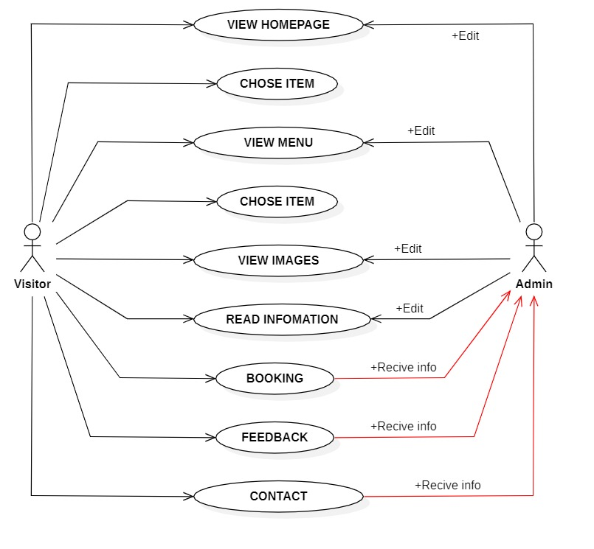

**TASK SHEET REVIEW 1**

|  |  |  |  |  |  |  |  |
| --- | --- | --- | --- | --- | --- | --- | --- |
| **Project Ref. No.:**  **eP/Advertisement** **Portal Management** **System/01** | | **Project Title:** | **Activity Plan** **Prepared** **By:** | **Date of Preparation of Activity Plan:** | | | |
| **Sr.No.** | **Task** | **Actual Start** **Date** | **Actual** **Days** | **Team** **Mate** **Names** | **Status** |
| 1 | Problem Statement | Amazing Bridges | Quang | 05/08/2020 | 1 | Quang | Completed |
| 2 | Analysis of Amazing Bridges requirements about the website | 05/08/2020 | 1 | Quang | Completed |
| 3 | The scope of the work (in brief) | 05/08/2020 | 1 | Quang | Completed |
| 4 | Architecture and design of the system | 05/08/2020 | 1 | Quang | Completed |
| 5 | Diagram of the website | 05/08/2020 | 1 | Quang | Completed |
| 6 | Task Sheet | 05/08/2020 | 1 | Quang | Completed |

|  |  |
| --- | --- |
| **Date:** | |
| Signature of Instructor:  **Mr. Ngo Phuoc Nguyen** | Signature of Team Leader:  **Nguyen Dong Thanh Quang** |

# SITE MAP

**Homepage**

**Our Team**

**Introduce 3 bridges famous**

**in the world**

**Booking Form**

**Introduce**

**Team’s Members**

**Booking**

**Longest Bridges**

**Oldest Bridges**

**Website**

**Contact**

**Contact Us**

**Our Location**

**Amazing Bridges**

**Highest Bridges**

**All**

**Tallest Bridges**

# Mock of the website

1. **Homepage**

|  |
| --- |
| **NAVIGATION BAR**  **(Navigation bar)**  **LOGO**  **(Navigation bar)**  **THE MOST AMAZING BRIDGES IN THE WORLD**  **FOOTER** |

1. **Amazing Bridges**

|  |
| --- |
| **LOGO**  **(Navigation bar)**  **NAVIGATION BAR**  **(Navigation bar)**  **Type of Bridge**  **Bridge Image**  **Information Site Map Comment**  **2**  **1**  **4**  **3** |

1. **Booking form**

|  |
| --- |
| **Booking form**  **Name:**  **Email:**  **Your address:**  **Start date:**  **Arrival date:**  **Ticket:**  **Your traffic type:**  **Book Now** |

1. **Our team**

|  |
| --- |
| **NAVIGATION BAR**  **(Navigation bar)**  **LOGO**  **(Navigation bar)**  OUR TEAM  **Member Image**  **Member Image**  **Member Image**  **Member Image** |

1. **Contact Us**

|  |
| --- |
| **NAVIGATION BAR**  **(Navigation bar)**  **LOGO**  **(Navigation bar)**  **Site Map**  **Contact** |

**TASK SHEET REVIEW 2**

|  |  |  |  |  |  |  |  |
| --- | --- | --- | --- | --- | --- | --- | --- |
| **Project Ref. No.:**  **eP/Advertisement** **Portal Management** **System/01** | | **Project Title:** | **Activity Plan** **Prepared** **By:** | **Date of Preparation of Activity Plan:** | | | |
| **Sr.No.** | **Task** | **Actual Start** **Date** | **Actual** **Days** | **Team** **Mate** **Names** | **Status** |
| 1 | Site map | Amazing Bridges | Hien | 10/8/2020 | 1 | Hien | Completed |
| 2 | Mock of the website | 10/8/2020 | 1 | Hien | Completed |
| 3 | Task sheet | 10/8/2020 | 1 | Hien | Completed |

|  |  |
| --- | --- |
| **Date:** | |
| Signature of Instructor:  **Ms. Ngo Phuoc Nguyen** | Signature of Team Leader:  **Nguyen Dong Thanh Quang** |

# WEBSITE DESCRIPTION

## Home page (Amazing Bridges on the left)

1. *Description*

*We provide 4 top kind of bridges with smooth effects.*

1. *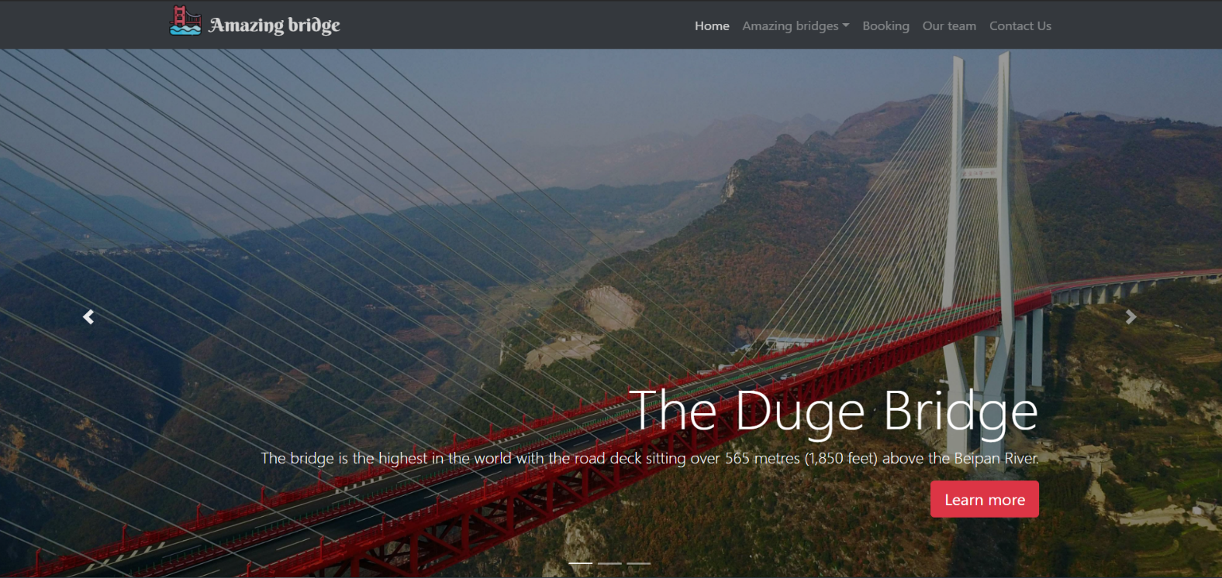Snapshot*

## Amazing Bridges

1. *Description*

*This is a place for content about the most amazing bridges in the world. We provided 4 birdges in each type and User can see each kind by click on link they want to see.*

1. *Snapshot*

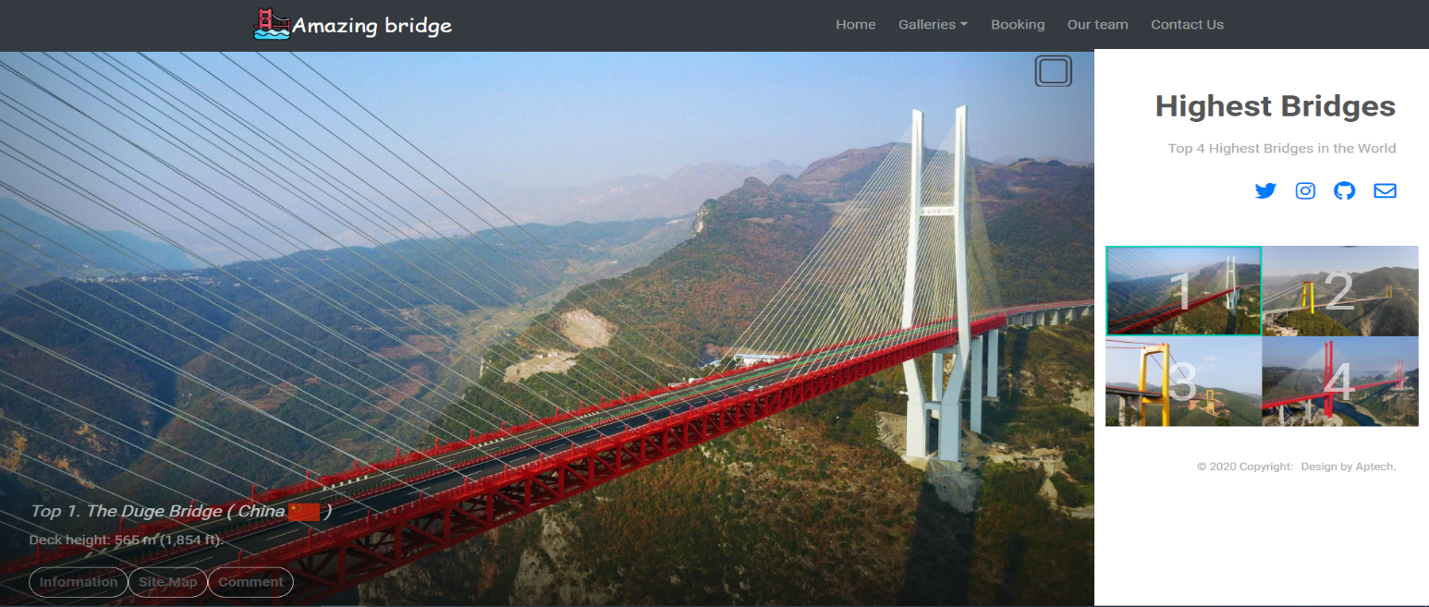

## Booking

1. *Description*

*If visitor want to travel or visit the bridges they like they can find some Flights or Bus near the bridges.*

1. *Snapshot*

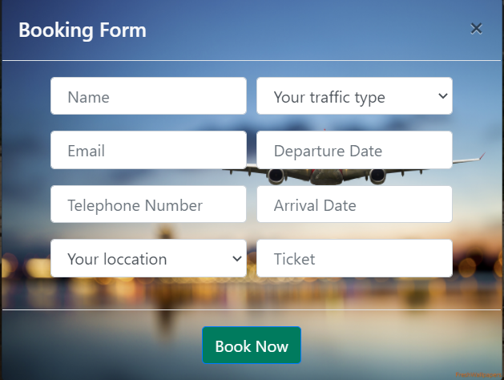

## Team

1. *Description*

*We always support user fastest if we can , so user can contact with any member develop team here. Everyone can contact us by Facebook, phone number and email.*

1. *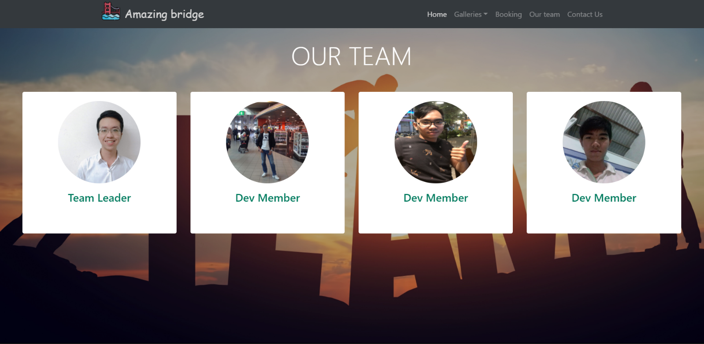Snapshot*

## Contact

1. *Description*

*Contact form help people connect with by normal way if they found wrong or error on our website or they want to help us with new idea or anything else…*

1. *Snapshot*

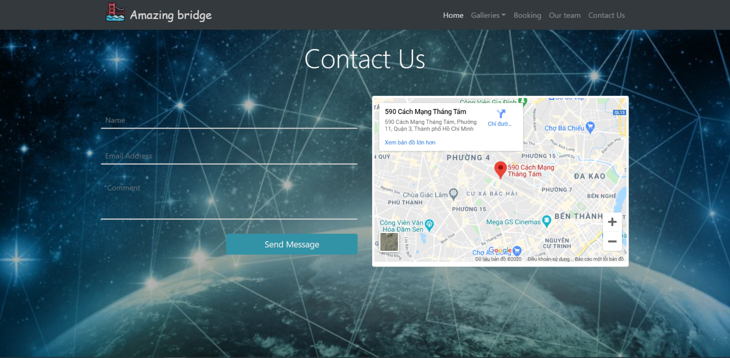

# JAVASCRIPT DESCRIPTION

This chapter will provide information about JavaScript function integrated in the website

## Slide

1. *Description*

We just use carousel for slide function. In the second snapshot that is the time next picture appear.

1. *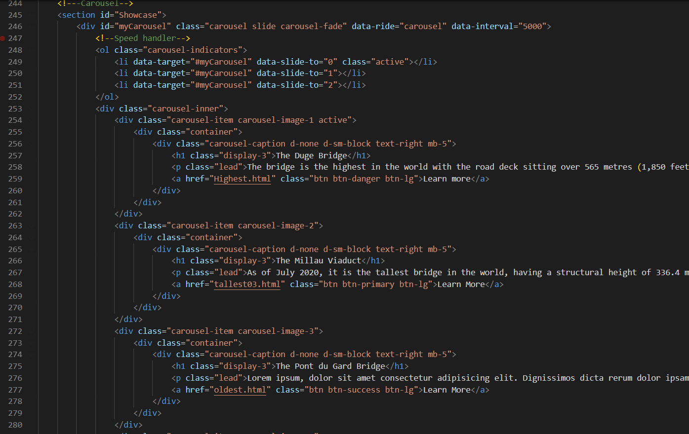Screenshot*

## Effect On Images At Amazing Bridges Section

1. *Description*

We want the User to be able to see the clearest images, so we use some code jquery for that.

1. *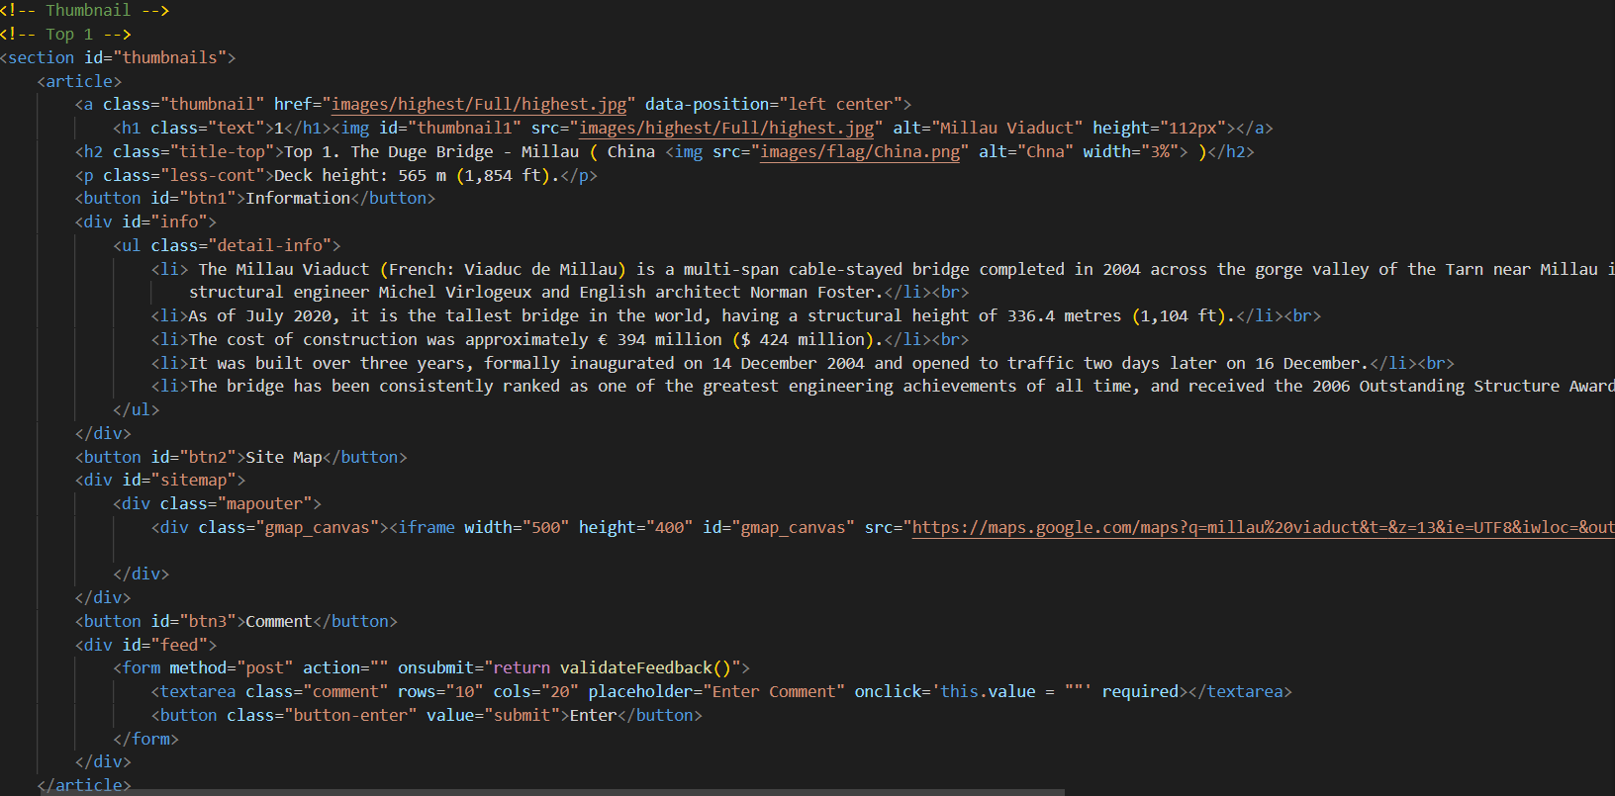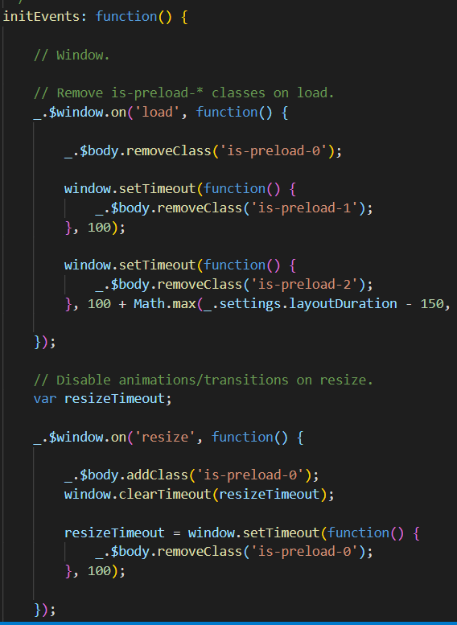Screenshot*

## Hide/Show information, sitemap and feedback

1. *Description*

*When user click on button on the images, they can see information, sitemap about the bridge they care, if they want to feedback they can write something and send this to us.*

1. 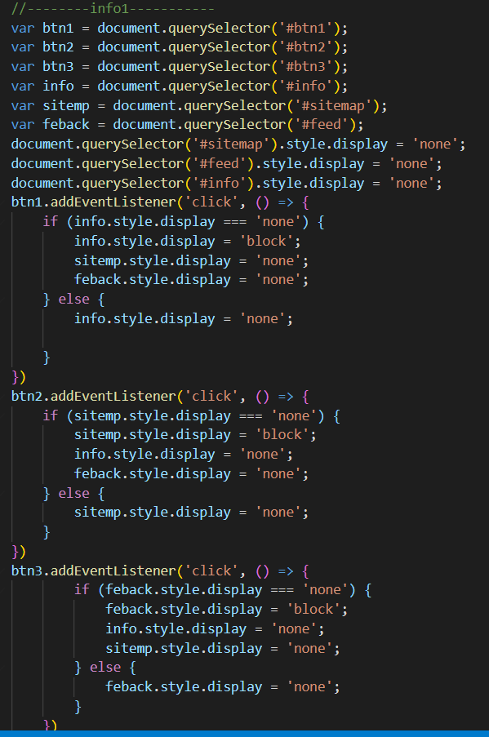*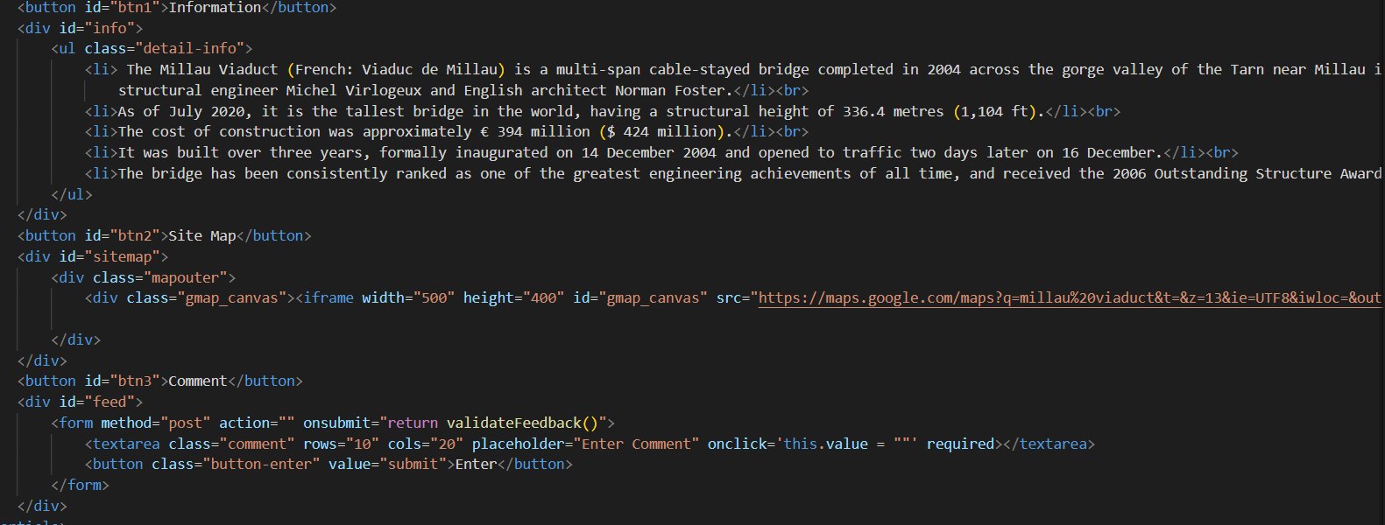Screenshot*

**TASK SHEET REVIEW 3**

|  |  |  |  |  |  |  |  |
| --- | --- | --- | --- | --- | --- | --- | --- |
| **Project Ref. No:**  **eP/Advertisement Portal Managament System/01** | | **Project Title:** | **Activity Plan Prepared by:** | **Date of Preparation of activity plan** | | | |
| **Sr. No.** | **Task** | **Actual start date** | **Actual days** | **Teammate name** | **Status** |
| 1 | Homepage | Amazing Bridges | T.Quang | 1/8/2020 – 5/8/2020 | 4 | V.Quang,  Khanh | Completed |
| 2 | Amazing Gridges | 1/8/2020 – 8/8/2012 | 7 | T.Quang,  Hien | Completed |
| 3 | Booking | 7/8/2020 – 11/8/2020 | 4 | V.Quang | Completed |
| 4 | Our Team | 7/8/2020 – 10/8/2020 | 3 | Khanh, V.Quang | Completed |
| 5 | Contact Us | 12/8/2020 – 15/8/2020 | 3 | V.Quang | Completed |